**Name : Abdullah Niazi**

**Roll No: 23F-0017**

**Question#1**

**Code:**

#include<iostream>

using namespace std;

int main() {

int choice;

char arr[20][20];

do {

cout << "Which Pattren You Want to Print ?" << endl;

cout << "Press 0 to Exit The Program" << endl;

cout << "Press 1 to Print a Filled Square" << endl;

cout << "Press 2 to Print a Hollow Square" << endl;

cout << "Press 3 to Print a Right Triangle" << endl;

cout << "Enter Your Choice (0-3) : "; cin >> choice;

if (choice <= 3 && choice >= 0) {

if (choice == 0) {

break;

}

if (choice == 1) {

for (int i = 0; i < 20; i++) {

for (int j = 0; j < 20; j++) {

arr[i][j]='*';

}

}

}

else if (choice == 2) {

for (int i = 0; i < 20; i++) {

for (int j = 0; j < 20; j++) {

if (i==0 || i==19 || j==0 || j == 19) {

arr[i][j]='*';

}

else {

arr[i][j]=' ';

}

}

}

}

else if (choice == 3) {

for (int i = 0; i < 20; i++) {

for (int j = 0; j < 20; j++) {

if (j < i) {

arr[i][j]='*';

}

else {

arr[i][j] = ' ';

}

}

}

}

else {

cout << "Enter a Valid Input" << endl;

}

}

else {

cout << "Enter a Valid Input" << endl;

}

for (int i = 0; i < 20; i++) {

for (int j = 0; j < 20; j++) {

cout << arr[i][j];

}

cout << endl;

}

}while(choice != 0);

return 0;

}

**Output:**

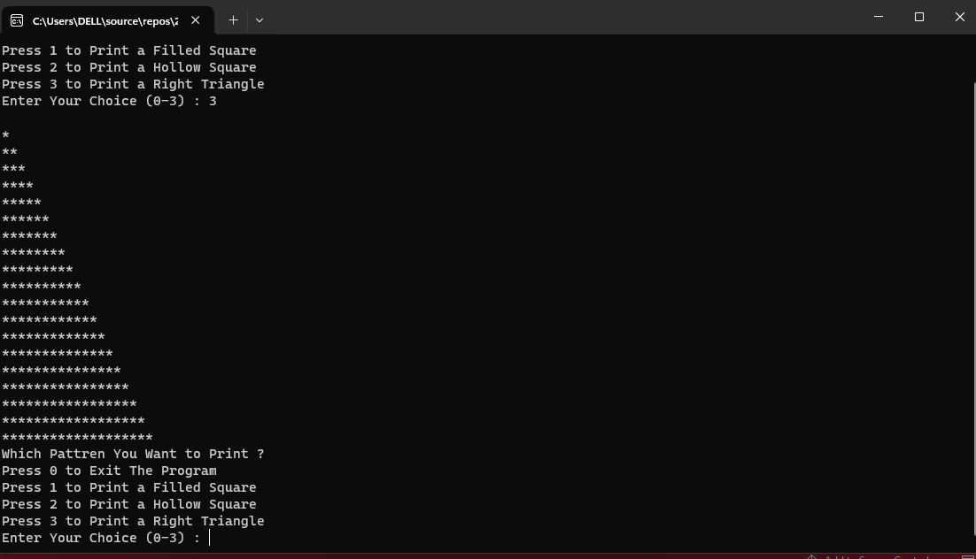

**Question#2**

**Code:**

#include<iostream>

using namespace std;

int main() {

int matrixA[2][2];

int matrixB[2][2];

int matrixC[2][2];

cout << "Matrix A" << endl;

for (int i = 0; i < 2; i++) {

for (int j = 0; j < 2; j++) {

cout << "Enter Element For Row #" << i + 1 << " Coloum #" << j + 1 << " : "; cin >> matrixA[i][j];

}

}

cout << "Matrix B" << endl;

for (int i = 0; i < 2; i++) {

for (int j = 0; j < 2; j++) {

cout << "Enter Element For Row #" << i + 1 << " Coloum #" << j + 1 << " : "; cin >> matrixB[i][j];

}

}

cout << "Matrix A" << endl;

for (int i = 0; i < 2; i++) {

for (int j = 0; j < 2; j++) {

cout << matrixA[i][j] << " ";

}

cout << endl;

}

cout << "Matrix B" << endl;

for (int i = 0; i < 2; i++) {

for (int j = 0; j < 2; j++) {

cout << matrixB[i][j] << " ";

}

cout << endl;

}

matrixC[0][0] = matrixA[0][0] * matrixB[0][0] + matrixA[0][1] * matrixB[1][0];

matrixC[0][1] = matrixA[0][0] * matrixB[0][1] + matrixA[0][1] * matrixB[1][1];

matrixC[1][0] = matrixA[1][0] * matrixB[0][0] + matrixA[1][1] * matrixB[1][0];

matrixC[1][1] = matrixA[1][0] * matrixB[0][1] + matrixA[1][1] * matrixB[1][1];

if (matrixC[0][0] == 1 && matrixC[1][1] == 1 && matrixC[0][1] == 0 && matrixC[1][0] == 0) {

cout << "Matrix B is Inverse of Matrix A" << endl;

}

else {

cout << "Matrix B is Not Inverse of Matrix A" << endl;

}

return 0;

}

**Output:**

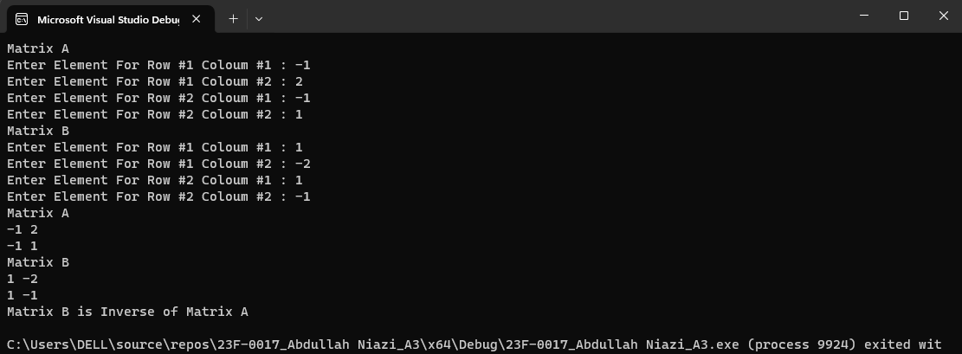

**Question#3**

**Code:**

#include<iostream>

#include<ctime>

#include<cstdlib>

using namespace std;

int main() {

srand(time(0));

const int size = 100;

int arr[size];

for (int i = 0; i < size; i++) {

arr[i] = rand() % 9901 + 100;

cout << arr[i] << " ";

}

cout << endl;

for (int i = 0; i < size; i++) {

int num = 0, temp = 0, power = 1, digits = 0,rem=0,sum=0;

num = arr[i];

temp = arr[i];

while (num > 0) {

num = num / 10;

digits = digits + 1;

}

while (temp > 0) {

rem = temp % 10;

for (int count = 0; count < digits; count++) {

power = power * rem;

}

sum = sum + power;

temp = temp / 10;

}

if (arr[i] == sum) {

cout << arr[i] << endl;

}

}

return 0;

}

**Output:**

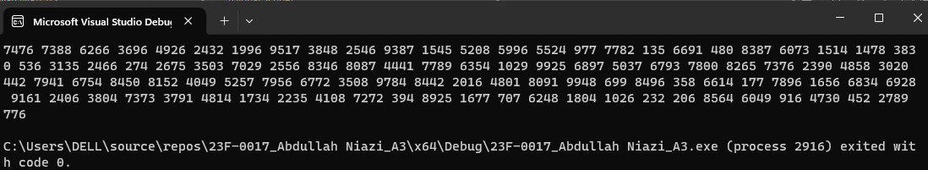

**Question#4**

**Code:**

#include<iostream>

#include<cstdlib>

#include<ctime>

#include<iomanip>

using namespace std;

int main() {

srand(time(0));

const int size = 100;

int arr[size];

int arr1[8] = {0};

for (int i = 0; i < size; i++) {

arr[i] = rand() % 201;

}

for (int i = 0; i < size; i++) {

if (arr[i] >= 175 && arr[i] <= 200) {

++arr1[7];

}

if (arr[i] >= 150 && arr[i] <= 174) {

++arr1[6];

}

if (arr[i] >= 125 && arr[i] <= 149) {

++arr1[5];

}

if (arr[i] >= 100 && arr[i] <= 124) {

++arr1[4];

}

if (arr[i] >= 75 && arr[i] <= 99) {

++arr1[3];

}

if (arr[i] >= 50 && arr[i] <= 74) {

++arr1[2];

}

if (arr[i] >= 25 && arr[i] <= 49) {

++arr1[1];

}

if (arr[i] >= 0 && arr[i] <= 24) {

++arr1[0];

}

}

cout << "Score Ranges "<<setw(4)<<" No. of Students" << endl;

int count = 0,j=24;

for (int i = 0; i < 8; i++) {

cout << count << " - " << count + j << setw(15) << arr1[i] << endl;

if (count == 150) {

j=25;

}

count = count + 25;

}

return 0;

}

**Output:**

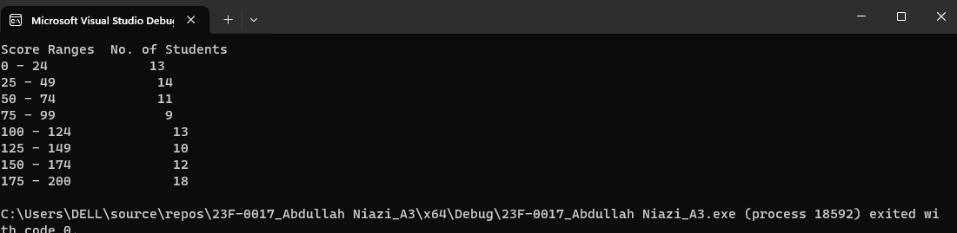

**Question#5**

**Code:** #include<iostream>

#include<iomanip>

using namespace std;

int main() {

char name[5][10];

int vote[5] = { 0 };

int totalvotes = 0,max=0,count=0;

for (int i = 0; i < 5; i++) {

cout<<"Enter Name of Candidate # "<<i+1<<" : "; cin >> name[i];

cout << "Enter Votes Received by Candidate # " << i + 1<<" : "; cin >> vote[i];

totalvotes = totalvotes + vote[i];

if (vote[i] > max) {

max = vote[i];

count = i;

}

}

cout << "Candidate "<<setw(5)<<" Votes Received "<<setw(5)<<" % of Total Votes" << endl;

for (int i = 0; i < 5; i++) {

float num = vote[i] ;

cout << name[i] <<setw(15) << vote[i] <<setw(20) << (num / totalvotes) * 100 << endl;

}

cout << "Total Votes " << totalvotes<<endl;

cout << "The Winner of The Election is " << name[count] << endl;

return 0;

}

**Output:**

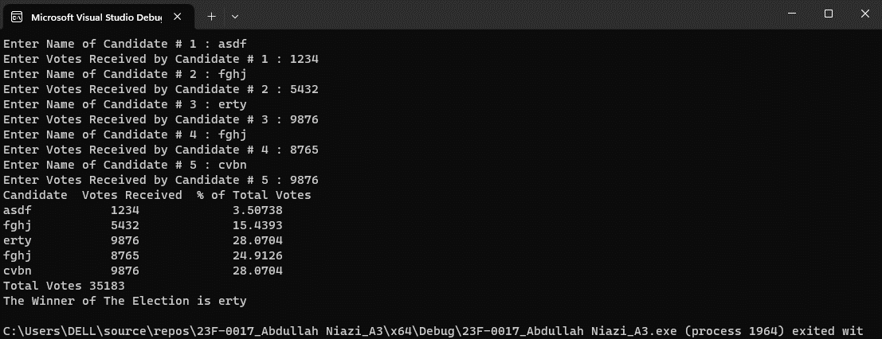

**Question#6**

**Code:**

#include <iostream>

using namespace std;

int main() {

float arr[12][2];

float sumhigh = 0, sumlow = 0;

int high = 0, low = 0;

for (int i = 0; i < 12; i++) {

cout << "Month #" <<i+1<< endl;

cout << "Enter Highest Temprature : "; cin >> arr[i][0];

cout << "Enter Lowest Temprature : "; cin >> arr[i][1];

sumhigh = sumhigh + arr[i][0];

sumlow = sumlow + arr[i][1];

if (arr[i][0] > high) {

high = arr[i][0];

}

low = arr[0][1];

for (int i = 0; i < 12; i++) {

if (arr[i][1] < low) {

low = arr[i][1];

}

}

}

cout << "Average Highest : " << sumhigh / 12 << endl;

cout << "Average Lowest : " << sumlow / 12 << endl;

cout << "Highest Temprature is : " << high << endl;

cout << "Lowest Temprature is : " << low << endl;

return 0;

}

**Output:**

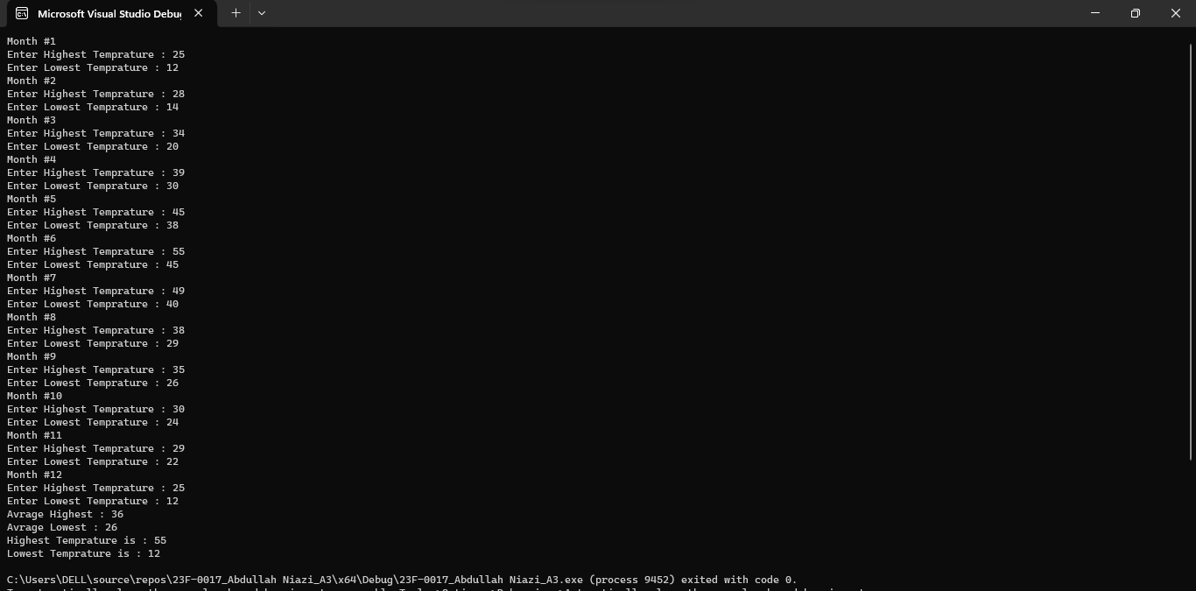

**Question#7**

**Code:**

#include<iostream>

#include<cstdlib>

#include<ctime>

using namespace std;

int main() {

srand(time(0));

const int size = 20;

int arr1[size];

int arr2[size];

int arr3[size + 1] = { 0 };

cout << "Number #1 : ";

for (int i = 0; i < size; i++) {

arr1[i] = rand() % 10;

cout << arr1[i]<<" ";

}

cout << endl;

cout << "Number #2 : ";

for (int i = 0; i < size; i++) {

arr2[i] = rand() % 10;

cout << arr2[i] << " ";

}

for (int i = size; i > 0; i--) {

arr3[i] = arr1[i - 1] + arr2[i - 1] + arr3[i];

if (arr3[i] >= 10) {

arr3[i - 1] = arr3[i - 1] + 1;

arr3[i] = arr3[i] % 10;

}

}

cout << endl;

if (arr3[0] > 0) {

cout << "Sum is More Than 21 Digits" << endl;

}

cout << "Sum is : ";

for (int i = 0; i <= size; i++) {

cout << arr3[i] << " ";

}

return 0;

}

**Output:**

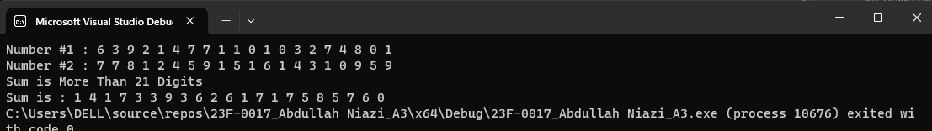

**Question#8**

**Code:**

#include<iostream>

using namespace std;

int main() {

char names[5][10] = { "Jason","Samantha","Ravi","Sheila","Ankit" };

float arr[5][7];

for (int i = 0; i < 5; i++) {

float sum = 0;

cout << "Name : " << names[i] << endl;

for (int j = 0; j < 7; j++) {

cout << "Enter Number Of Miles Run in Day # " << j+1 <<" : "; cin >> arr[i][j];

}

for (int k = 0; k < 7; k++) {

sum = sum + arr[i][k];

}

cout << "Total Miles Run in a Week : " << sum << endl;

cout << "Average Miles Run Each Day : " << sum / 7<<endl;

}

return 0;

}

**Output:**

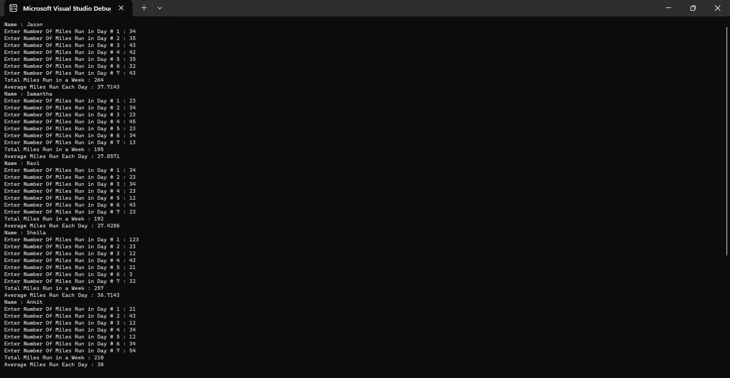

**Question#9**

**Code:**

#include<iostream>

#include<cstdlib>

#include<ctime>

using namespace std;

int main() {

int arr[20][20];

srand(time(0));

for (int i = 0; i < 20; i++) {

for (int j = 0; j < 20; j++) {

arr[i][j] = rand() % 10;

cout << arr[i][j] << " ";

}

cout << endl;

}

for (int i = 0; i < 20; i++) {

for (int j = 0; j < 18; j++) {

int temp = arr[i + 1][j + 1];

if (temp > arr[i][j] && temp > arr[i][j + 1] && temp > arr[i][j + 2]) {

if (temp > arr[i + 1][j] && temp > arr[i + 1][j + 2]) {

if (temp > arr[i + 2][j] && temp > arr[i + 2][j + 1] && temp > arr[i + 2][j + 2]) {

cout << "Maximum Peak : " << temp << " Found at Row #" << i + 1 <<" Coloum #" << j + 1 << endl;

}

}

}

if (temp < arr[i][j] && temp < arr[i][j + 1] && temp < arr[i][j + 2]) {

if (temp < arr[i + 1][j] && temp < arr[i + 1][j + 2]) {

if (temp < arr[i + 2][j] && temp < arr[i + 2][j + 1] && temp < arr[i + 2][j + 2]) {

cout << "Minimum Peak : " << temp << " Found at Row #" << i + 1 << " Coloum #" << j + 1 << endl;

}

}

}

}

}

return 0;

}

**Output:**

**Question#10**

**Code:**

#include<iostream>

#include<iomanip>

using namespace std;

int main() {

char arr[13][5];

for (int i = 0; i < 13; i++) {

for (int j = 0; j < 5; j++) {

arr[i][j] = '*';

}

}

cout << "Avalible Seats" << endl;

cout <<setw(10)<<"A"<<setw(4)<<"B" << setw(4) << "C" << setw(4) << "D" << setw(4) << "E"<< endl;

for (int i = 0; i < 13; i++) {

cout << "Row " <<setw(2)<<i + 1;

for (int j = 0; j < 5; j++) {

cout << setw(4) <<arr[i][j] ;

}

cout << endl;

}

int tickettype,row,seatNo,error=0;

cout << "Press 1 For First Class" << endl;

cout << "Press 2 For Business Class" << endl;

cout << "Press 3 For Economy Class" << endl;

cout << "Enter Your Ticket Type : "; cin >> tickettype;

if (1<= tickettype && tickettype <=3) {

if (tickettype == 1) {

cout << "Enter Row Number (1-2) : "; cin >> row;

cout << "Enter Seat Number (1-5) : "; cin >> seatNo;

if (row == 1 || row == 2 && seatNo >= 1 && seatNo <= 5) {

arr[row - 1][seatNo - 1] = 'X';

}

else {

cout << "Enter a Valid Input" << endl;

error++;

}

}

if (tickettype == 2) {

cout << "Enter Row Number (3-7) : "; cin >> row;

cout << "Enter Seat Number (1-5) : "; cin >> seatNo;

if (row >= 3 && row <= 7 && seatNo >= 1 && seatNo <= 5) {

arr[row - 1][seatNo - 1] = 'X';

}

else {

cout << "Enter a Valid Input" << endl;

error++;

}

}

if (tickettype == 3) {

cout << "Enter Row Number (8-13) : "; cin >> row;

cout << "Enter Seat Number (1-5) : "; cin >> seatNo;

if (row >= 8 && row <= 13 && seatNo >= 1 && seatNo <= 5) {

arr[row - 1][seatNo - 1] = 'X';

}

else {

cout << "Enter a Valid Input" << endl;

error++;

}

}

if (error == 0) {

cout << "Your Selected Seat" << endl;

cout << setw(10) << "A" << setw(4) << "B" << setw(4) << "C" << setw(4) << "D" << setw(4) << "E" << endl;

for (int i = 0; i < 13; i++) {

cout << "Row " << setw(2) << i + 1;

for (int j = 0; j < 5; j++) {

cout << setw(4) << arr[i][j];

}

cout << endl;

}

}

}

else {

cout << "Enter a Valid Input" << endl;

}

return 0;

}

**Output:**

